**Demo 6**

**Create Data Tables**



**Steps to be followed:**

**Step 1: Open the Excel file**

* 1. Open the file named **Data Tables.xlsx**

**Step 2: Creating a Data table with Excel**

**Problem Statement**

Rod is a Sales Manager of XYZ company and wants to determine the profit he will make if he sells products at two different selling prices to two different customers.

2.1 Create a new table with columns as the number of units sold and rows as the SP per unit. Start the table in E10

2.2 Insert the profit formula in the first cell (E10) of the output table

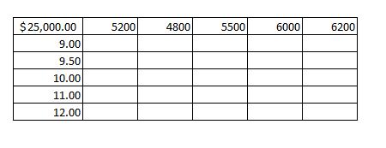

2.3 Select the new table. Now choose the Data table in What-if analysis under the Data tab

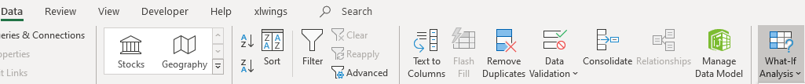

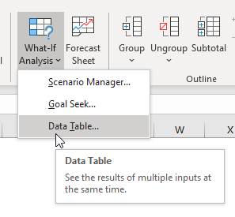

2.4 Select Row input cell and Column input cell. Click OK

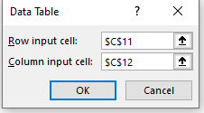

2.5 The data is filled in the data table as shown below

